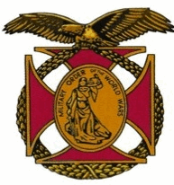

Meeting of the General J. P. Holland Chapter of the MOWW
January 7th, 2017

The chapter met at the Bernardo Heights Country Club at 1100

1135: The meeting was called to order by Chapter Commander, Nick Herbka. Acting Chaplain Carl Swepston offered the invocation and our Gust Speaker, LCDR Rob Kihm, USN led the Pledge of allegiance. Tom Lettington read the Preamble.

1145: The Chapter Commander introduced the members and guests.

1155: Under New Business, Tom Lettington moved that the Chapter donate $500 annually to the RBVMA to assist with the cost of a storage unit to store equipment owned by RBVMA and used in their memorial services. Andre’ LeCault seconded the motion and it passed unanimously by a voice vote.

1200: Lunch was served

1230: The Companions heard a presentation by LCDR Kihm about his career experiences as a US Navy Fighter plot, flying F-18s, with a focus on his time at TOP GUN and his service about aircraft carriers in the middle east. He took questions and made some very interesting unclassified remarks about the newest fighter aircraft, the F-35. After his talk, the Chapter awarded our speaker a Certificate of Appreciation and a Challenge Coin.

1335 Carl Sweptson offered the benediction

1345: The meeting was adjourned

